**EDUCATION YEAR COŞKUN ERTEPINAR SECONDARY SCHOOL 7TH GRADE 1ST TERM 2ND SELECTIVE ENGLISH EXAM**

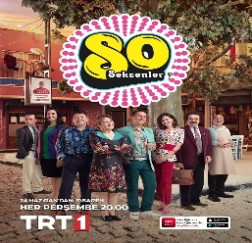A.Match the TV programmes with the pictures. 15 pts

|  |  |  |  |  |
| --- | --- | --- | --- | --- |
| Cookery programme | Talk show | cartoon | TV series | News |

1______________ 2_______________ 3_______________ 4_______________ 5______________

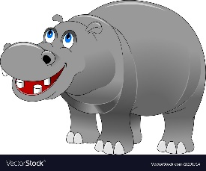B.Match the wild animals with the pictures. 15 pts

|  |  |  |  |  |
| --- | --- | --- | --- | --- |
| eagle | owl | hippopotamus | lizard | polar bear |

1_____________ 2____________ 3____________ 4________________ 5______________

C. Complete the sentences with the words below. 18 pts

|  |
| --- |
| brilliant Prize born awards graduated studied |

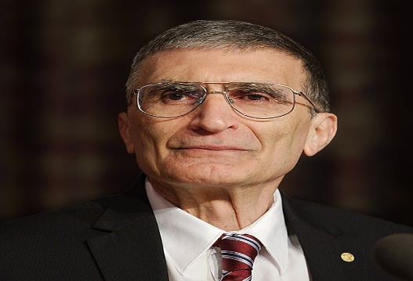

Aziz Sancar was ________________ in 1946 in Mardin, Türkiye. He was a __________________ student at school. He _______________ Medicine at İstanbul University. He __________________ from the university in 1969. In 1971, he entered the Department of Biochemistry Graduate Program at John Hopkins University. He wrote many scientific articles and got lots of _________________ for his studies. In 2015, he got a Nobel _________________ for his works.

D. Write the past forms of the verbs. 12 pts

|  |  |
| --- | --- |
| REGULAR | IRREGULAR |
| study - ________________  finish - _________________  receive - _________________ | become - _________________  have - _________________  find - _________________ |

|  |  |
| --- | --- |
| 1. . They are herbivores and mammals. They have a long trunk and white tusks. They usually live in the jungles in Africa. They weigh about 4-5 tones.  Which animal is it?  a) c)   1. d) | 5. I’m a wild animal. I’m usually green and brown. I’m a carnivore. I have got sharp and long teeth. I eat meat.   1. c) 2. d) |
| 2. I _____________ watching sitcoms to talk shows. Avrupa Yakası is my favourite.   1. prefer 2. prefers 3. didn’t prefer 4. doesn’t prefer | 6. Alexander Graham Bell _______________ the telephone.   1. invented 2. stayed 3. moved 4. became |
| 3. I. Soap a. show  II. Talk b. programme  III. Weather c. opera  IV. Sports d. forecast  Which of the following matching is correct?   1. I – c II – a III – b IV – d 2. I – c II – a III – d IV - b 3. I – a II – d III – c IV – b 4. I – a II – c III – d IV - b | 7. Barış Manço __________ born in 1943 in İstanbul.   1. were 2. was 3. did 4. didn’t |
| 4. We _______________ protect the endangered animals.   1. should 2. shouldn’t 3. were 4. didn’t   NOTE : Each question on the back page is 5 points. | 8. .I’m watching my favourite _______________. I learn about animals and their habitat.   1. sitcom 2. news 3. reality show 4. documentary   Balonlar düz dolguyla  GOOD LUCK |